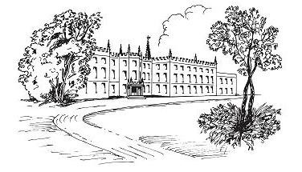

RENISHAW HALL & GARDENS
COURTYARD CAFÉ

North East Derbyshire’s “hidden gem” is nestled in between the villages of Renishaw & Eckington.

The Stables Courtyard Café offers delicious fresh seasonal dishes, beautiful surroundings, and the most perfect place to relax and unwind.

Free Wi-Fi whilst you dine. Password – Cafe Guest

We hope you enjoy your visit.

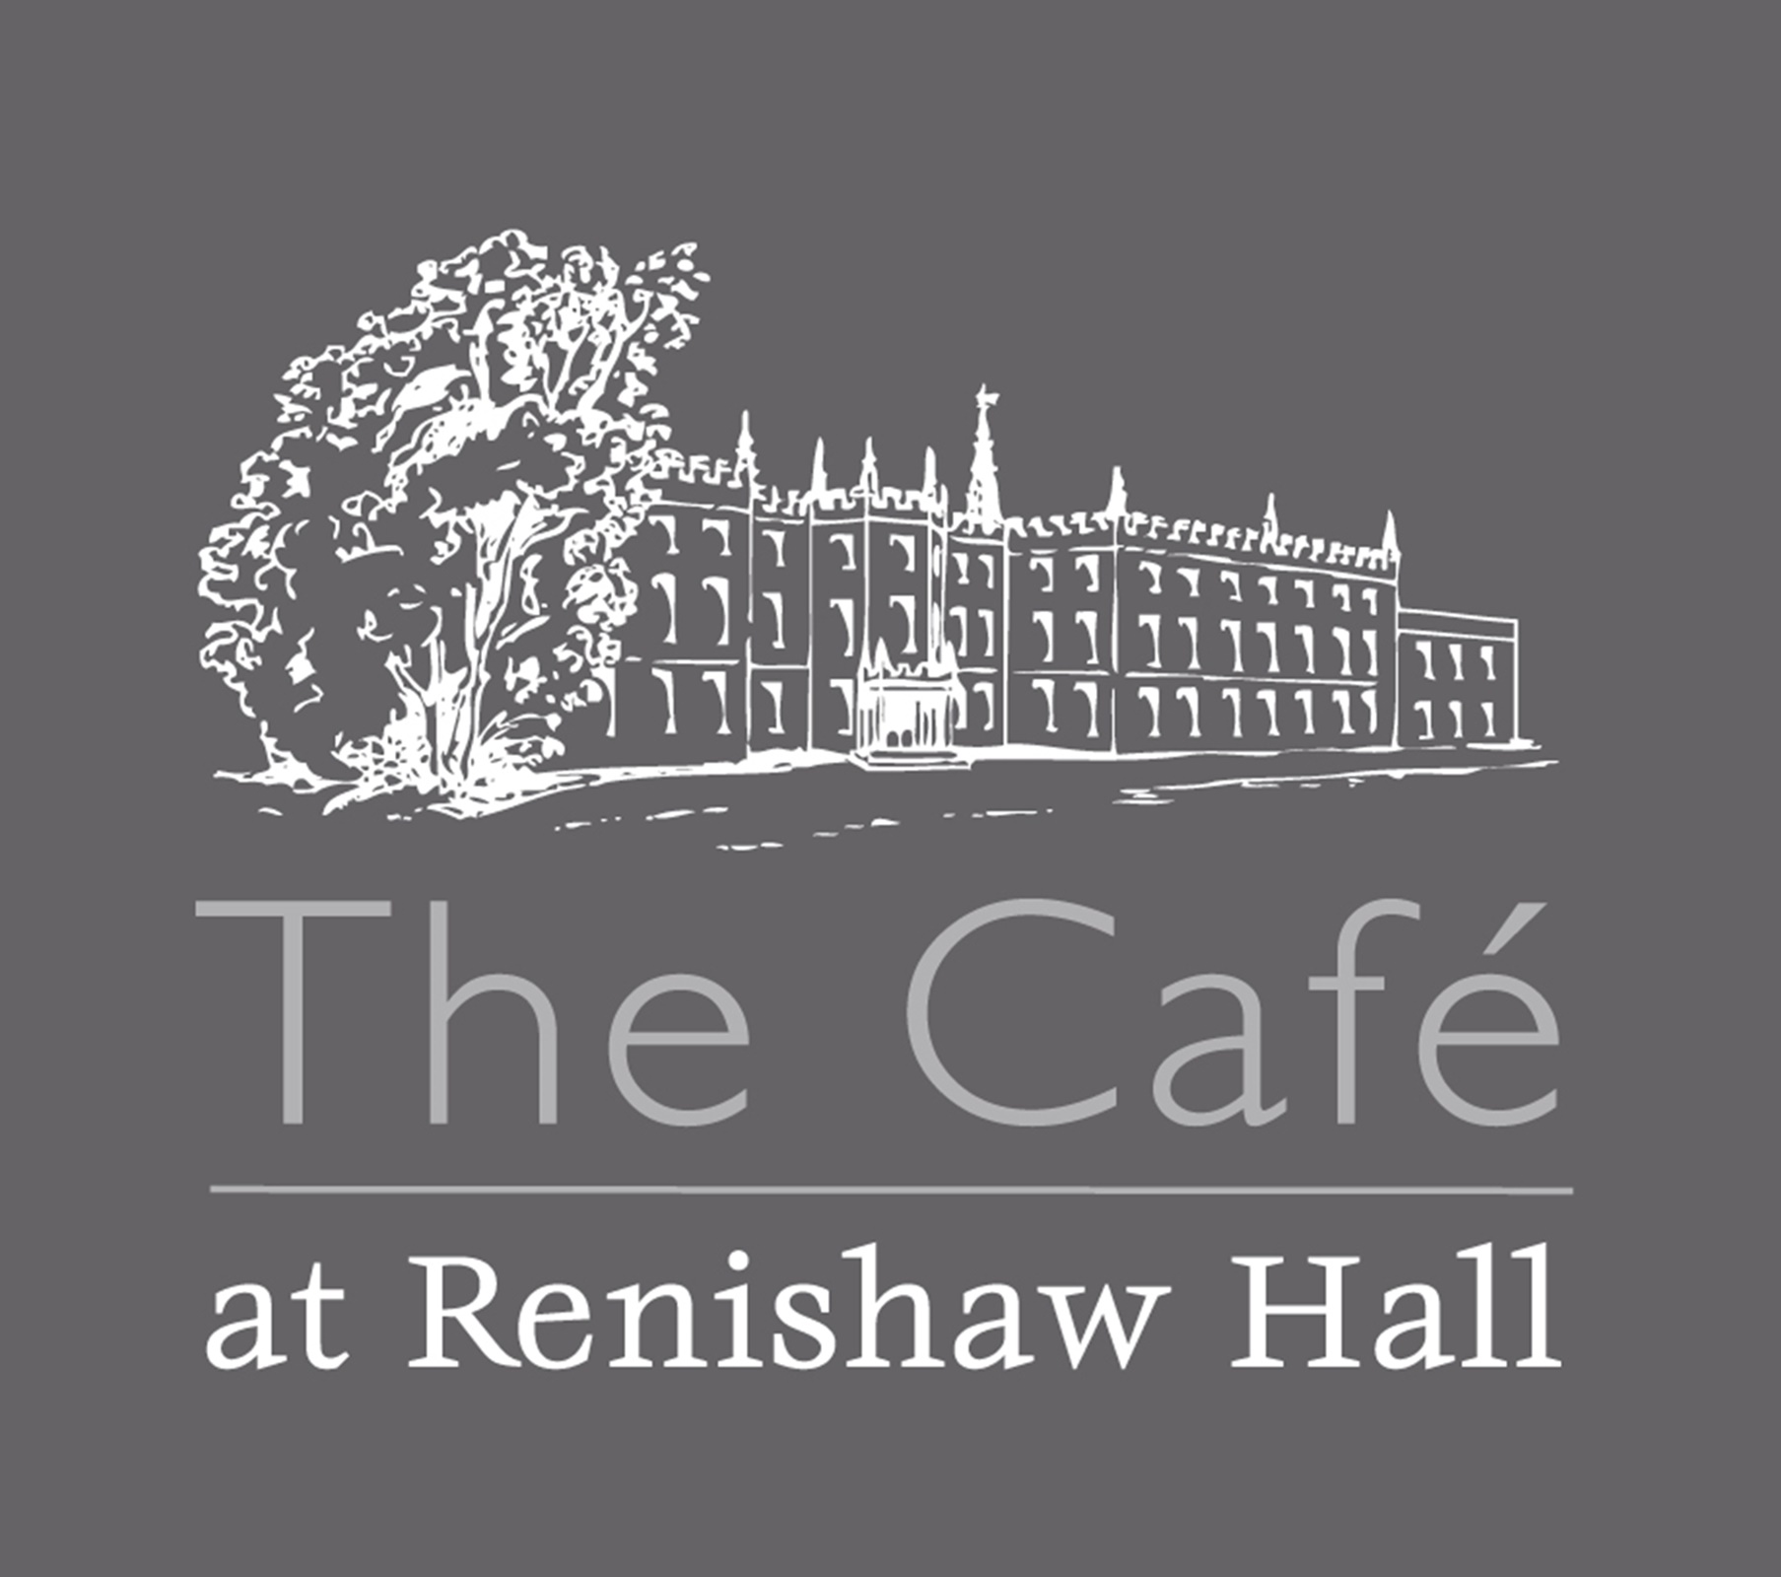
Breakfast Menu served from 9am
Please speak to a member of staff about any dietary requirements before ordering

“Sitwell” Full English VE £13
Succulent Cumberland Sausages, Crispy Bacon Rashers, Hashbrown, Eggs – fried or scrambled or poached, Baked Beans, Roasted Tomato, Mushrooms, and your choice of toast (white or brown bread)
English breakfast (Smaller portion) VE £10
Eggs Benedict £9
Toasted English Muffin topped with Wiltshire ham, two Poached Eggs and delicious Hollandaise Sauce.
Eggs Florentine VE £9
Toasted English Muffin topped with Sauteed Spinach, two Poached Eggs and delicious Hollandaise Sauce.
Eggs Royale £12
Toasted English Muffin topped with Smoked Salmon, two Poached Eggs and delicious Hollandaise Sauce.

Breakfast Baps - Choice of up to 2 items (extras 75p per item) £7
Bacon, Egg, Sausage, Mushrooms.
Eggs on toast – 2 eggs on toast (extras 75p per item) £6
Toasted Teacake served with butter (served all day) £4
Toast £3
White or Brown Bread served with butter, jam, or marmalade GF option available

VE – Vegetarian VG -Vegan GF - Gluten Free DF - Dairy Free
Lunch Menu served until 3pm
Please speak to a member of staff about any dietary requirements before ordering
Soup of the day served with a fresh crusty roll VE/VG/GF/ DF £8
Bruschetta VG/VE/GF £9
- Topped with Renishaw Hall grown heritage tomatoes,
basil & garlic salsa OR
- Topped with hummus, avocado, toasted sunflower seeds & chimichurri sauce
Jacket Potato with 2 fillings VG/VE/GF/DF £9
Fillings: - Tuna, cheese, beans & coleslaw
Salad of the day GF/VE £10
Quiche of the day, served with chips, side salad & coleslaw VE £10
Panini served with side salad & coleslaw VE/VG/GF £10
- Cheese & Tomato, Tuna & Cheese, Ham & Cheese
Chips available as an extra side £3.50
Pie of the day served with chips, peas or beans and gravy £13
Chicken Goujons, served with chips, side salad & coleslaw £10
Eggs Benedict £9
Toasted English Muffin topped with Wiltshire ham, two Poached
Eggs and delicious Hollandaise Sauce.
Fish and Chips (Served on Fridays only) £14
Haddock served with chips, peas, tartar sauce, bread & butter

For the Children –
Fishfingers, Vegetarian sausage, or Chicken Goujons & Chips £7.25
Vegetarian-VE Vegan- VG Dairy free-DF Gluten free-GF

RENISHAW HALL & GARDENS
Cream Tea – Subject to availability £7.50
Freshly made scone served with butter, strawberry jam, clotted cream, and your choice of freshly brewed tea or coffee

Quintessential or Savoury Afternoon Tea Pre-booking only £24.95
Luxury Afternoon Teas Pre-booking only £29.95
Vegetarian, Vegan & Gluten Free options
Quintessential - Mini quiche, four finger sandwiches per person, with chefs’ choice of fillings from the list below. (Except for special requests / dietaries)
Cheddar, Egg mayo & watercress, Tuna mayo & sliced cucumber, Ham, Cream cheese & cucumber, Roast beef. (Subject to availability).
French chocolate petit fours, Fruit or Plain Scone, Butter, Cream & Jam, Macaron, Chocolate & orange slice, Mini red velvet gateau and your choice of freshly brewed tea or coffee.

Savoury - Four finger sandwiches per person, with chefs’ choice of fillings from list below. (Except for special requests / dietaries)
Cheddar, Egg mayo & watercress, Tuna mayo & sliced cucumber, Ham, Cream cheese & cucumber, Roast beef. (Subject to availability).
Pork pie, Mini quiche, Scotch egg, Sausage roll, Spring roll, Goat cheese & fig parcels, Chutney.
**Luxury Teas are accompanied with a glass of Renishaw Hall Award-Winning bubbly. **

Afternoon Tea & Café Gift Vouchers are available to purchase on the Website
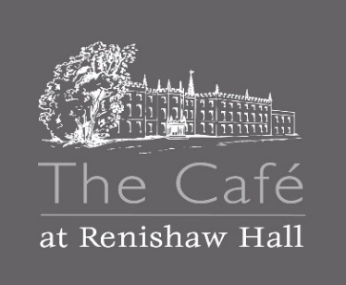
Drinks Menu
Specialty Tea’s £3.25

English Breakfast Sapphire Earl Grey Egyptian Mint
Decaffeinated Ceylon Dragonwell Green Persian Pomegranate
White Pear and Ginger

Coffee
Americano & Espresso £3.50
Cappuccino, Latte, Flat White £3.75
Babycino £2.75
Flavored Syrups 75p

Hot Chocolate £3.75
Childs Hot Choc £2.50
Still and Sparkling Bottled Water £2.00
Belvoir Presse £2.95
(Elderflower, Ginger Beer, Raspberry Lemonade)
Coke, Diet Coke, Sprite, Fanta £2.25
Fruit shoot £1.95
Renishaw Hall Award – Winning Wine (makes a perfect gift too!)
White Wine £17.99/bottle £4.95 /125ml glass £6.45 175ml
Rose Wine £17.99/bottle £4.95 /125ml glass £6.45 175ml
Red Wine £22.00/bottle £5.95 /125ml glass £7.45 175ml
Sparkling White £33.00/bottle £6.95 /125ml glass £9.45 175ml
Sparkling Rose £33.00/bottle £6.95 /125ml glass £9.45 175ml

Even Cider – Renishaw apples £3.75
Farmers Blonde Pale Ale (citrus & summer fruit aromas) £4.95

