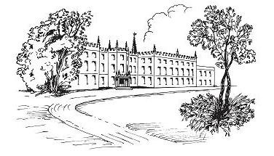

RENISHAW HALL & GARDENS
Afternoon tea menu

North East Derbyshire’s “hidden gem” is nestled in between the villages of Renishaw & Eckington.
The Courtyard Café offers delicious, fresh and elegant Afternoon Teas, beautiful surroundings, and the most perfect place to relax and unwind.

We hope you enjoy your visit.

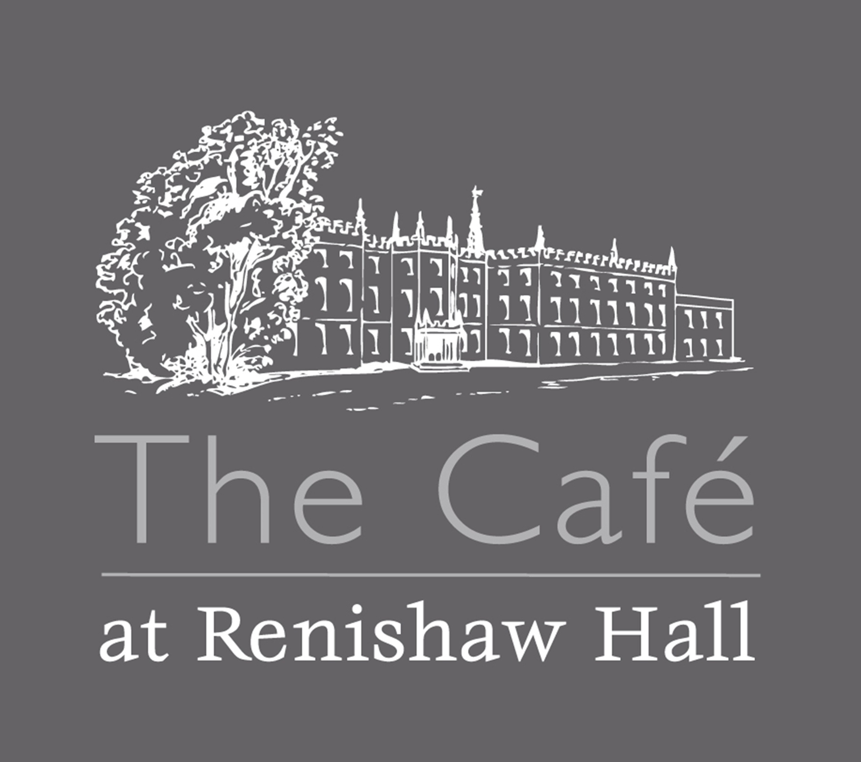

RENISHAW HALL & GARDENS
Cream Tea – Subject to availability £7.50
Freshly made scone served with butter, choice of jam, clotted cream, and your choice of freshly brewed tea or coffee.
Quintessential or Savoury Afternoon Tea Pre-booking only £24.95
Luxury Afternoon Tea Pre-booking only £29.95

Vegetarian, Vegan & Gluten Free options are available
Quintessential - Finger sandwiches:-
fillings :- Roast beef & horseradish mayo, honey roast ham, truffled egg mayonnaise & cress, smoked salmon with cream cheese & cucumber. (Subject to availability)
Mini quiche and mini sausage roll, warm fresh baked sultana (or plain) scone with butter, cream & jam, selection of macaron, miniature cakes, petit fours and fruit, with your choice of freshly brewed tea or coffee.

Savoury - Finger sandwiches:-
fillings :- Roast beef & horseradish mayo, honey roast ham, truffled egg mayonnaise & cress, smoked salmon with cream cheese & cucumber. (Subject to availability)
Mini pork pie and mini quiche served with onion chutney, scotch egg, cheese straws, fresh baked sausage roll, warm fresh baked sultana (or plain) scone with butter, cream, jam and fresh fruit, with your choice of freshly brewed tea or coffee.

**Luxury Afternoon Teas are accompanied with a glass of Renishaw Hall Award-Winning wine. **

Afternoon Tea Gift Vouchers are available to purchase on the Website
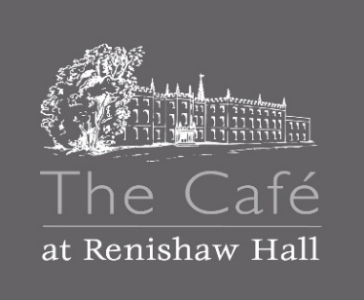
Drinks Menu
Specialty Tea’s £3.00

English Breakfast Sapphire Earl Grey Egyptian Mint
Decaffeinated Ceylon Dragonwell Green Persian Pomegranate
White Pear and Ginger

Coffee
Americano & Espresso £3.25
Cappuccino, Latte, Flat White £3.50
Babycino £2.50
Flavored Syrups 50p

Hot Chocolate £3.50
Childs Hot Choc £2.00
Still and Sparkling Bottled Water £2.00
Belvoir Presse £2.75
(Elderflower, Ginger Beer, Raspberry Lemonade)
Coke, Diet Coke, Sprite, Fanta £2.00
Fruit shoot £1.75
Renishaw Hall Award Winning Wine (makes a great gift too!)
White Wine £17.99/bottle £4.95 /125ml glass £6.45 175ml
Rose Wine £17.99/bottle £4.95 /125ml glass £6.45 175ml
Red Wine £22.00/bottle £5.95 /125ml glass £7.45 175ml
Sparkling White £33.00/bottle £6.95 /125ml glass £9.45 175ml
Sparkling Rose £33.00/bottle £6.95 /125ml glass £9.45 175ml

Even Cider – Renishaw apples £3.75
Farmers Blonde Pale Ale (citrus & summer fruit aromas) £4.95

